Day 1 :---------------------------------------------------------------27/04/2026

Computer:- Computer is an electronic machine, which takes input and gives output amd perform arithmetic(+-*/%) and logical(and or not ><=) operations.

Electricity
AC - Alternative (Electric)
DC - Direct (Electronic)

----------------------------------------------
Computer's Language
LLL (Low Level Language)
1st Gen
Machine Level/Binary / 0 and 1
10100101011111111001001010101
Computer:- Fast Execution
Human:- Hard To Understand

2nd Gen
1010101111111101011010101011101010101
MD , CD , DIR , TREE etc (Menomics)
Assembly Language

-----------------------------------------------

HLL (High Level Language)/ Programming Language
3rd Gen (POP :- Procedure Orientted Programming)
C , COBOL , FORTRAN , BASIC , LISP etc
They are very near to english language
Translator:- Interpreter / Compiler
HLL -- convert --> LLL
They are not secure

4th Gen - OOP (Object Oriented Programming)
C++ , Java , Python , Ruby , C# etc
They are very near to english language
Translator:- Interpreter / Compiler
HLL -- convert --> LLL

5th AI

------------------------------------------------
English
Alphabet -> Words -> Sentence -> Paragraph

Python
Alphabets, Keywords
Numbers, -> Variable, -> Instruction-> Program
Symbols Constant

------------------------------------------------
Alphabet
a,b,c,d--z , A,B,---Z (Case Sensitive)
a != A
AMAN , aman , Aman
a => 1100001 => 97
A => 1000001 => 65
print Print X
------------------------------------------------
Numbers:-
26 , -28 , 34.67 , 5+j7 , 5/3 etc
------------------------------------------------
Special Symbols:-
~!@#$%^&*()_+}":> etc
------------------------------------------------
Keywords (Reserved Words) 36 Keywords
if , else , for , while etc
------------------------------------------------

a = 10 ( a is assign to 10 )
Variable , Constant
vary(change) + able
a = 10
a = 12

------------------------------------------------

a = 10 # Instruction

------------------------------------------------

a = 10
b = 20 # PROGRAM
c = a+b
print(c) # 30

------------------------------------------------
Python is a interpreted , dynamic programming language

a = 10
a = 'aman'
------------------------------------------------
https://python.org

Day 2 :---------------------------------------------------------------28/04/2026
# Single Line Comment
"""
Multi line comments

Built-in Functions
print , input , int , float , type
PRINT

print("Hello India")
print("Mohan Singh")

a = 100
Hello = 9999
print("a")
print(a)
print("Hello")
print(Hello)

print("Hello ")
print("India")

# \n => new line
print("Hello \nIndia")

a = 100
print("Hello ",a,"Bye")

a = 12
b = 13
c = a+b
print("Addition :",c)

INPUT
input() => it is use to ask value from the user
input() returns the text/string value

a = input("Enter A Number : ")
b = input("Enter B Number : ")
c = a+b
print("Addition :",c)

INT
int() => it is use to convert a value into numeric

a = int( input("Enter A Number : ") )
b = int( input("Enter B Number : ") )
c = a+b
print("Addition :",c)

int can not handle float/decimal/point value

FLOAT

a = float( input("Enter A Number : ") )
b = float( input("Enter B Number : ") )
c = a+b
print("Addition :",c)

# float can also support point values

# WAP to calculate the gross salary of an employee where
HRA is 20% and DA is 30% of his basic salary.
HINT:- Gross_Salary = Basic_Salary + HRA + DA

bs = float( input("Enter Basic Salary : ") )
hra = bs*0.20
da = bs*0.30
gs = bs+hra+da
print("Gross Salary :",gs)

TYPE
a = float( input("Enter a Number : ") )
print( a )
print( type(a) )

a = 10
print( type(a) )
a = 17.3
print( type(a) )
a = 'aman'
print( type(a) )
a = True
print( type(a) )

# WAP to calculate the area of circle
# HINT:- area = pie*raidus*radius

"""
radius = float(input("Enter Radius : "))
area = 3.14*radius*radius
print("Area :",area)

Day 3 :---------------------------------------------------------------29/04/2026

"""
Python Operators

a+b => a,b (operands) , + (oprerator)
operator do operation on operands

1- Arithmetic Operator
+ - * / % // **

a = 7
b = 5
print( a+b )
print( a-b )
print( a*b )
print( a/b )
print( a%b ) # % modulus (to calculate the remainder)
print( 11%4 )
print( a//b ) # // truncation/floor division (it divides and print the result after removing point/decimal value)
print( 11//4 )
print( 57//6 )
print( 2**5 ) # ** Exponential ( to calculate the power (2 to the power 5))
print( 5**3 )

2- Assignment Operator
= , += , -= , *= etc
a = 10
a += 1 # => a = a+1
a *= 2 # => a = a*2
print(a)

3- Relational / Conditional Operator
> < >= <= == != (Return Boolean Answer)
Boolean => True/False

a = 7
b = 5
print( a>b )
print( a<b )
print( a>=b )
print( a<=b )
print( a==b ) # == is equal to
print( a!=b ) # != is not equal to

4- Membership Operatort (check existance)
in , not in ( Return Boolean Answer )

a = "aman"
b = "amankumar"
print( a in b )
print( "ankum" in b )
print( "ka" in b )
print( "ka" not in b )

a = [10,20,30]
b = [10,20,30]
print( a in b )
a = 20
print( a in b )
a = [10,20,30]
b = [10,20,[10,20,30],30]
print( a in b )

5- Identity Operator (Check Exact Match)
is , is not (Return Boolean Value)

a = "aman"
b = "aman"
c = "amankumar"
print( a is b )
print( a is c )
print( a is not c )

# difference of == and is
# == is use to match the content
# 'is' is use to match the reference/address

a = [1,2,3] # object (object always takes a new memory)
b = [1,2,3]
print( a is b )
a = 10
b = 10 # it will not take a new memory
print( a is b )

6- Logical Operator
and , or , not , xor

and => if both inputs are True, Then the output is True
otherwise False
a = 7
b = 5
print( a>b and a<b )
print( a>b and a<20 )
print( a>10 and a<b )

and => if both inputs are False, Then the output is False
otherwise True

a = 7
b = 5
print( a>b or a<b )
print( a>b or a<20 )
print( a>10 or a<b )

not:- not operator is also called the invertor gate/operator
not will reverse the input
not will convert True to False and vice-versa
not can accept only and only one input

a = 7
b = 5
print( a>b )
print( not a>b )
print( not False )
print( not b>a )

"""
Day 4 :---------------------------------------------------------------30/04/2026

"""
6- Logical Operator
and , or , not

a = 7
b = 5
print( a>b and b>a )
print( a>b or b>a )
print( not a>b )

print( int(True) )
print( int(False) )

print( bool(1) )
print( bool(0) )
print( bool(False) )
print( bool() )
print( bool(235) )
print( bool(-5634) )
print( bool('aman') )
print( bool(345.5467) )

a = 7
b = 5
print( a and b )
print( b and a )

a = 7
b = 5
print( a or b )
print( b or a )

a = 46
print( not a )
print( not 0 )

7- Bitwise Operator
and -> &
or -> |
not -> ~

a = 21
b = 56
print( a & b ) # 16
print( a | b ) # 61

a = 23
b = 44
print( a & b ) # 4
print( a | b ) # 63

Xor
ye or operator ki tarah kam karta lekin agar 1 1 0 aagay to 0 kar dega
1 1 0
00 0

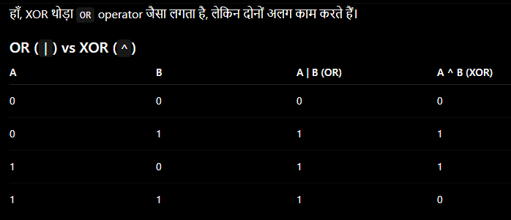
"""

Day 5 :---------------------------------------------------------------05/04/2026
"""
Bitwise Operator
and -> &
or -> |

a = 23
b = 28
print( a&b ) # 20
print( a|b ) # 31

shift operators
right shift operator >>
left shift operator <<

a = 21
print( a>>1 ) # 10
print( a>>2 ) # 5

a = 23
print( a>>1 ) # 11
print( a>>2 ) # 5
print( a>>3 ) # 2

a = 9
print(a<<1) # 18
print(a<<2) # 36

a = 4
print(a<<1) # 8
print(a<<2) # 16
print(a<<3) # 32

NOT ( ~ )
-(x+1)

a = -5
print( ~a )

# ----------------------------------------------

Python Data Type

Number
int (integer) do not support point/decimal values
45 , 78 , -435 , 76
float (decimal values)
34.456 , -23.57 , 546.0 etc
binary ( binary number has only 2 digits 0 and 1 )
0b101011
a = 0b1001
a = 0b101010111
a = 0b10101
Octal Number ( 0,1,2,3,4,5,6,7 )
0o253 , 0o367
Hexadecimal Number ( 0,1,2,3,4,5,6,7,8,9,A,B,C,D,E,F )
0x254 , 0x1FA , 0x3DCA
Complex Number ( a+jb )
3+7j , 5+8j
a = 3+7j
print( a )
print( a.real )
print( a.imag )
print( a )

String
'A' , "Aman" , "A" , 'Aman' # for one line
a = "347537434"
a = '''jdbjdf'''
a = '''tyiher
kjdfgsdjkfbjsdf for multiple lines
dfdsvfkhsdf
sdfhvdskjfsd
fsdvfkjsdf
sdjkfsdkjf
'''

Boolean
True , False

Sequence Data Type
List , Tuple
li = [23,5,6,78]
t = (423,54,67,89,23)

Hash Table's Type
Set , Dictionary
s = {34,54,67,89}
d = {1:345 , 2:64 , 3:67}

print( True + True*False )
# 1 + 1*0
# 1+0
# 1

"""

Priority | Operators
Highest | ()
 | **
 | +x, -x, ~x
 | *, /, //, %
 | +, -
 | <<, >>
 | &
 | ^
Lowest | `

BODMAS जैसा सोचो
- ()
- **
- * / // %
- + -
- Shift << >>
- Bitwise & ^ |
और same level वाले normally left → right चलते हैं।

Day 6 :---------------------------------------------------------------06/05/2026
"""
Control Statements
if , if_else , Nested if_else , elif , Complex Condition
Looping:- for , while loop

IF
Syntax:-
if condition:
True_Statement

if 10>5:
print("Hello India")

if 10>50:
print("Hello India")

if 10>5:
print("Hello India")
print("World")

if 10>50:
print("Hello India")
print("World")

IF_ELSE
Syntax:-
if condition:
True_Statement
else:
False_Statement

if 10>5:
print("Hello")
else:
print("Bye")

if 10>50:
print("Hello")
else:
print("Bye")

# WAP to find greater value b/w two

a = int(input("Enter A Number : "))
b = int(input("Enter B Number : "))
if a>b:
print("Greater Value :",a)
else:
print("Greater Value :",b)

# WAP to check an entered Number is Even/Odd

num = int(input("Enter A Number : "))
if num%2==0:
print("Even")
else:
print("Odd")

Nested IF_Else
Syntax:-
if condition:
if condition:
True_Statement
else:
False_Statement
else:
if condition:
True_Statement
else:
False_Statement

# WAP to check A number is Positive, Negative or Zero

num = int(input("Enter A Number : "))
if num>0:
print("Positive")
else:
if num<0:
print("Negative")
else:
print("Zero")

# WAP to check an entered character is Vowel/Consonant
HINT:- A,E,I,O,U

ch = 'I'
if ch=='A':
print("Vowel")
else:
if ch=='E':
print("Vowel")
else:
if ch=='I':
print("Vowel")
else:
if ch=='O':
print("Vowel")
else:
if ch=='U':
print("Vowel")
else:
print("Consonant")

else:
if
ELIF

ch = 'Z'
if ch=='A':
print("Vowel")
elif ch=='E':
print("Vowel")
elif ch=='I':
print("Vowel")
elif ch=='O':
print("Vowel")
elif ch=='U':
print("Vowel")
else:
print("Consonant")

Complex Condition (write all conditions together using logical operator)

ch = 'M'
if ch=='A' or ch=='E' or ch=='I' or ch=='O' or ch=='U':
print("Vowel")
else:
print("Consonant")

ch = 'W'
if ch in "AEIOUaeiou":
print("Vowel")
else:
print("Consonant")

# input return string value
"""

a = int( input("Enter A Number: ") )
b = int( input("Enter B Number: ") )
print( a+b )

Day 7 :---------------------------------------------------------------07/05/2026
"""
Looping:-
Loop:- is use to perform/execute a task again n again
for a finite times

FOR , WHILE
for
Syntax:-
for variable_name in range(start,stop,step):
statement

# range is a collection
print( *range(1,5,1) )
print( *range(1,11,1) )
print( *range(2,21,2) )

Example
for a in range(1,5,1):
print("Hello")

for a in range(1,11,1):
print(a)

for a in range(2,22,2):
print(a)

# Print Table of A Number

num = int(input("Enter A Number: "))
for a in range(1,11,1):
print(a*num)

for i in range(1,7,1):
print(i)

for i in range(1,7,2):
print(i)

# By default step = 1
for i in range(1,7):
print(i)

# By default step = 1
for i in range(5,9):
print(i)

# By default step = 1
# By default start = 0
for i in range(5): # if only one value (consider stop value)
print(i)

for i in range(): # raise an error (required at least one value)
print(i)

# WAP to print counting from 1 to 10

for i in range(1,11):
print(i)

# WAP to print counting from 1 to N (user input)
n = int(input("Enter A Number: "))
for i in range(1,n+1):
print(i)

# WAP to print factors of a number.
# HINT:- 12 => 1,2,3,4,6,12

n = int(input("Enter A Number: "))
for i in range(1,n+1):
if n%i==0:
print(i)

# WAP to count the factors of a number
# HINT:- 12 => 1,2,3,4,6,12 => 6 factors

count = 0
n = int(input("Enter A Number: "))
for i in range(1,n+1):
if n%i==0:
print(i)
count=count+1
print("Total Factors :",count)

# WAP to check an entered number is Prime or Not

count = 0
n = int(input("Enter A Number: "))
for i in range(1,n+1):
if n%i==0:
count=count+1
if count==2:
print("Prime")
else:
print("Not Prime")

"""
Day 8 :---------------------------------------------------------------08/05/2026
"""
For Loop
break , continue , pass , else

for i in range(1,11):
print(i)

# break:- It exit from the current loop
for i in range(1,11):
if i==4:
break
print(i)

# break:- It exit from the current loop
for i in range(1,11):
print(i)
if i==4:
break

# break:- It exit from the current loop
for i in range(1,11):
if i%5==0:
break
print(i) yaha check karna hai ki agar print if k andar likhege to kya hoga

# continue:- Continue takes the cursor to the next itteration
# continue go for the next loop's itteration
# continue will skip the instruction after the continue
# Continue ka matlab hota hai ki uske aage jitney bhi instruction likhe hoy hai unhe skip karna ( fir se loop par jana)

for i in range(1,7):
if i==3:
continue
print(i)

for i in range(1,7):
print(i)
if i==3:
continue

# continue:- Continue takes the cursor to the next itteration
# continue go for the next loop's itteration
# continue will skip the instruction after the continue

for i in range(1,11):
if i%3==0:
continue
print(i)

# pass:- pass do nothing (pass just PASS the cursor to the next line)

for i in range(1,6):
if i==3:
pass
print(i)

if 10>5:
pass

print("Hello")

ELSE
# ELSE will work with FOR
for i in range(1,7):
print(i)
else:
print(0)

for i in range(1,7):
if i==4:
break
print(i)
else:
print(0)

# else will work only if, FOR complete his task without any break

for i in range(1,7):
if i==4:
continue
print(i)
else:
print(0)

for i in range(1,7):
if i==4:
continue
else:
print(0)

for i in range(1,7):
if i==4:
break
else:
print(0)

count = 0
for i in range(1,7):
if i==4:
continue
count=count+1
else:
count=count+1
print(count)

count = 0
for i in range(1,7):
if i==4:
break
count=count+1
else:
count=count+1
print(count)

"""

Day 9 :---------------------------------------------------------------11/05/2026
"""
While Loop

initialization
while condition:
statements
incr/decr

Example:-
a = 1
while a<5:
print("Hello")
a = a+1

a = 1
while a<=5:
print("Hello")
a = a+1

a = 1
while a<=10:
print(a)
a = a+1

num = int(input("Enter A Number : "))
a = 1
while a<=10:
print(a*num)
a = a+1

num = int(input("Enter A Number : "))
a = 1
while a<=num:
print(a)
a=a+1

# WAP to print factors of a number
# HINT:- 12 => 1,2,3,4,6,12

num = int(input("Enter A Number : "))
a = 1
while a<=num:
if num%a==0:
print(a)
a=a+1

# WAP to count the number of factors

count = 0
num = int(input("Enter A Number : "))
a = 1
while a<=num:
if num%a==0:
print(a)
count+=1
a=a+1
print("Total Factors :",count)

# WAP to check a Number is Prime or Not

count = 0
num = int(input("Enter A Number : "))
a = 1
while a<=num:
if num%a==0:
count+=1
a=a+1
if count==2:
print("Prime")
else:
print("Not Prime")

While loop is used for custom conditions

ch = 'Y'
while ch in 'Yy':
name = input("Enter Name : ")
add = input("Enter Address : ")
ch = input("Do You Want To Continue (Y/n) : ")

# WAP to add all digits of number
# HINT:- 273 => 2+7+3 => 12 Result

num = int(input("Enter A Number : "))
add = 0
while num>0:
rem = num%10
add = add+rem
num = num//10
print("Addition of Digits :",add)

# WAP to reverse a Number

num = int(input("Enter A Number : "))
add = 0
while num>0:
rem = num%10
add = add*10+rem
num = num//10
print("Addition of Digits :",add)

"""

Day 10 :---------------------------------------------------------------12/05/2026
"""
Looping Programming Questions
# WAP to check a number is Palindrome
# HINT:- 121 => Reverse => 121 Palindrome
123 => Reverse => 321 Not Palindrome

num = int(input("Enter A Number : ")) # 121
copy = num
add = 0
while num>0:
rem = num%10
add = add*10+rem
num = num//10
if copy==add:
print("Palindrome")
else:
print("Not Palindrome")

# WAP to check a number is Armstrong
# Armstrong
# 371 => 3**3 + 7**3 + 1**3 => 27+343+1 => 371
# 153 => 1**3 + 5**3 + 3**3 => 1+125+27 => 153

num = int(input("Enter A Number : "))
copy = num
add = 0
while num>0:
rem = num%10
add = add+rem**3
num = num//10
if copy==add:
print("Armstrong")
else:
print("Not Armstrong")

# WAP to check a number is BUZZ
HINT:- 145 => 1! + 4! + 5! => 1 + 24 + 120 => 145
5! => 5*4*3*2*1 => 120

num = int(input("Enter A Number : ")) # 145
add = 0
copy = num
while num>0:
rem = num%10

fact = 1
for i in range(1,rem+1):
fact=fact*i

add = add+fact
num = num//10
if add==copy:
print("BUZZ Number")
else:
print("Not BUZZ Number")

"""

Day 11 :---------------------------------------------------------------13/05/2026
"""
Collection:- List, Tuple , Set , Dictionary , String , range

Sequence Data Type:-
List , Tuple

List:- A list is a collection of hetreogenous (different) elements
li = [23,56,78,95,79]

li = [23,56,78,95,79]
li = [23,'Aman',67.35,True,'A',3+8j]
li = []
li = list([54,67,89])
li = list((11,22,33))
li = list()
print( li )
print( type(li) )

List works on INDEX
forward 0,1,2,3..
backward -1,-2,-3.
list_name[index]

li = [23,54,56,456,89]
print(li)
print( li[2] )
print( li[-2] )

List supports Slicing
list_name[start_index : stop_index : step]

li = [23,54,56,456,89,34,45,56]
print(li)
print( li[3:6:1] )
print( li[3:6:2] )
print( li[3:6] ) # step = 1
print( li[ :4] ) # start = 0
print( li[ 5: ] )
print( li[ : ] )

List can be Replicate
li = [1,2,3,4]
print( li )
print( li*3 )

List can be Traverse

li = [1,2,3,4,5,6,7,8,9,10]
for x in li:
print(x**3)

Built-in Functions
sum , min , max , len

li = [23,56,78,64,53,23,12,54,78]
print( li )
print( sum(li) )
print( min(li) )
print( max(li) )
print( len(li) )
print( sum(li)/len(li) )

List's Method
append , insert , extend

li = [1,2,3,4,5]
print(li)
li.append(99)
print(li)
li.insert(2,77)
print(li)
li2 = [11,22,33]
li.extend(li2)
print(li)

list's Method
pop , remove , del (keyword) , clear

li = [23,45,67,78,89,36,65,45]
print(li)
li.pop()
print(li)
li.pop(2) # pop(index)
print(li)
li.remove(89) # remove(value)
print(li)
del li[3]
print(li)
li.clear()
print(li)

List's Method
sort , reverse

li = [67,23,54,65,78,89]
print(li)
li.reverse()
print(li)
li.sort()
print(li)
li.sort( reverse=True )
print(li)

count , index

li = [23,54,56,56,47,56,24,54]
print(li)
print( li.count(56) )
print( li.index(24) )

"""

Day 12 :---------------------------------------------------------------14/05/2026
"""
Tuple:- Tuple is also a collection of hetregenous elements
like list.
- Size is change in tuple because it block the memory and suppose we have list in tuple and we want to add new items in list so thus we can say that tupple can be change the size .
- Tupple mai reference store hote hai islie hm index par value change nahi kar sakte
Syntax:-
t = (34,45,67,89,86)

Ways to create a tuple
t = (23,45,56,78,90)
t = (34,67.34,True,'Aman',3+8j)
t = ()
t = tuple([23,45,56,78,89])
t = tuple((23,45,56,78,87))
t = tuple()
print(t)
print( type(t) )

Tuple works on INDEX
forward (0,1,2,3,..), backward (-1,-2,-3,..)
tuple_name[index]

t = (23,45,56,78,90)
print(t)
print( t[2] )
print( t[-4] )

Tuple can be sliced
tuple_name[start:stop:step]

t = (23,45,56,78,90)
print(t)
print( t[2:4:1] )
print( t[2:4] )
print( t[:4] )
print( t[3:] )
print( t[:] )

Tuple can be Replicate
t = (23,45,56,78,90)
print(t)
print( t*3 )

Tuple can be Traverse
t = (23,45,56,78,90)
print(t)
for x in t:
print(x)

Built-in functions
sum , max , min , len

t = (2,45,6,89,5)
print(t)
print(sum(t))
print(max(t))
print(min(t))
print(len(t))

Tuple's Methods
count , index

t = (23,45,67,78,45,56)
print( t )
print( t.count(45) )
print( t.index(78) )
print( t.index(45,2) ) # (value,start_index)

Tuple is immuteable (You can not change anything in the tuple)
- Does not allow append , insert , delete , pop because Tuple is immutable
Tuple is faster than the list because of its immuteablity

Nested List/Tuple

li = [23,34,45,56,78]
li = [[34,45,67],3,54,67,[45,56,67]]
t = (34,56,78,45)
t = (23,45,(34,546,67),[456,778],'Aman')

li = [23,45,[4,5,678],45]
print(li)
print( li[2] )
print( li[2][2] )

List Comprehension
li = [ x for x in range(1,11) ]
li = [ x for x in range(2,21,2) ]
li = [ x**3 for x in range(1,11) ]
li = [ x if x%2==0 else 'odd' for x in range(1,21) ]
print(li)

t = (32,43,[44,55,6],76)
t[2].append(99)
print( t )

add = 0
t = (33,56,67,86,76)
print( t )
for x in t:
add=add+x
print(add)

t = (33,56,67,86,76)
a = t[2]
for x in t:
if x>a:
a = x
print(a)

"""

Day 13 :---------------------------------------------------------------18/05/2026

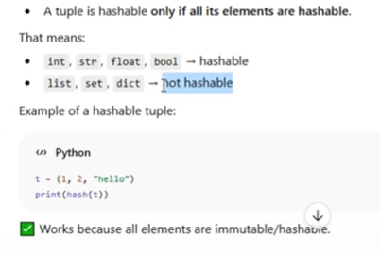

"""
SET:- Set is also a collection of unique hetregenous elements and mutable
- It does not allow the repeatation of element that’s why it is unique
- Duplicacy ko hatane k lie hash ko use karta hai internally
- Agar duplicate value hai to phle vale memory address ki value ka address par data rakhta rahega
- Set has no index
- Set cannot be sliced
- Set does not support replication because it has only unique replication
- Set can be Traverse using for loop
- HASHABLE means jo immutable hai
- Pop return the value and random delete
Syntax:-
set_name = {ele1,ele2,ele3..}

Ways to create a SET

s = {23,45,56,89}
s = {23,45.78,'Aman',True}
s = {1,2,3,4,4,3,2,2,1,1,2,2,3,3,2,3}
s = {3,56,67,45,324,34,34,45,67,56,78}
s = set()
s = set([23,56,46,87,54,34])
s = set((23,56,46,87,54,34))
print(s)
print( type(s) )

SET has no INDEX
SET can not be sliced
SET can not be replicate
But, Set can be Traversed

s = {2,45,67,45,2,78,879,63}
print( s )
for a in s:
print(a)

Built-in functions
max, min , len , sum

s = {2,45,67,45,2,78,879,63}
print( s )
print( sum(s) )
print( max(s) )
print( min(s) )
print( len(s) )

SET's Method
add , update , pop(remove random element but probably is remove first element in set) , remove , clear , discard

s = {4,56,67,42,65}
print(s)
s.add(99)
print(s)
s1 = {11,22,33,56}
s.update(s1)
print(s)
s.pop()
print(s)
s.remove(99)
print(s)
# s.remove(101) # error because 101 key is not in the set
s.discard(11)
print(s)
s.discard(101)
print(s)
s.clear()
print(s)

Methods
intersection , union , difference , symmetric_difference

s1 = {1,2,3,4,5,6}
s2 = {4,5,6,7,8,9}
print( s1.intersection(s2) )
print( s1.union(s2) )
print( s1.difference(s2) ) #-> 1235 - 234 => 15
print( s1.symmetric_difference(s2) ) # 1235 - 234 => 154

SET's opertor

s1 = {1,2,3,4,5,6}
s2 = {4,5,6,7,8,9}
print( s1&s2 ) # intersection
print( s1|s2 ) # Union
print( s1-s2 ) # difference
print( s1^s2 ) # symmetric_difference

Dictionary:- Dictionary is a collection of key:value pairs

d = {1:23,2:56,5:78,'Aman':890,7:754}
print( d )
print( type(d) )

d = {1:23,2:56,5:78,'Aman':890,7:754}
print( d )
print( d[5] )
print( d['Aman'] )
print( d[754] ) # throw an exception (KeyError: Not Found)

Dictionary has no index, it works on Key
Key can not be duplicate
Value can be duplicate
Its not compulsory, key should be contiguous
Dictionary can not be sliced
But, Dictionary can be Traverse

dic = {1:23,2:456,3:567,4:63,5:57}
print( dic )
for a in dic: # by default keys will be traverse
print(a)

Dictionary's Method
keys , values , items

dic = {1:23,2:456,3:567,4:63,5:57}
print( dic )

for a in dic.keys():
print(a)

for a in dic.values():
print(a)

dic = {1:23,2:456,3:567,4:63,5:57}
print( dic )

for a in dic.items():
print(a)

dic = {1:23,2:456,3:567,4:63,5:57}
print( dic )

for k,v in dic.items():
print(k , v)

"""

Day 14 :---------------------------------------------------------------19/05/2026
"""
Dictionary

dic = { 1:347 , 2:384 , 3:675 , 4:347 }
print( dic )
dic = { 1:347 , 2:384 , 2:675 , 4:347 } # value will update for duplicate key
print( dic )
print( dic.keys() )
print( dic.values() )
print( dic.items() )

Methods:-
get , clear , update , pop(it must need 1 argument ) , popitem

d = {1:24,2:45,3:65}
print( d )
print( d[2] )
# print( d[5] ) # it will raise an error because key 5 is not available
print( d.get(5) ) # Return None if key not found
print( d.get(5,"Not Available") )
print( d.get(3,"Not Available") )

d = {1:24,2:45,3:65}
d.clear() # remove all items
print( d )

d = {1:24,2:45,3:65}
print( d )
d1 = {2:99,4:46,5:78,6:78}
d.update(d1)
print( d )
d.pop(5) # it will remove value of key 5 (remove item)
print(d)
d.popitem() # it will remove the last element/item
print( d )

copy

d = {1:23 , 2:45 , 3:68 , 4:47}
print( d )
d1 = d.copy() // both address are different and take both another memory address
print( d1 )
d1[2] = 99
print(d)
print(d1)

String:- String is also a collection of characters/symbols
st = "wdgsjk23457($&^"

st = "amankumar"
st = ""
st = str(123)
st = "aman123@gmail.com"
print( st )

String works on INDEX
both forward and backward

st = "amankumar"
print( st )
print( st[4] )
print( st[-6] )

String can be sliced
st = "amankumar"
print( st )
print( st[2:7] )

String Support Replication

st = "amankumar"
print( st )
print( st*3 )

String supports Traversing
st = "amankumar"
print( st )
for s in st:
print(s)

st = 'amankumar'
st = "amankumar"
st = '''
amankumar
is
my
younger
brother'''

print(st)

Built-Functions
sum , max , min , len
a,b,c--z => ASCII Values=> 97,98,99---122
A,B,C--Z => ASCII Values=> 65,66,67---90

st = "AmanKumar"
print(st)
print( len(st) )
print( max(st) )
print( min(st) )

String's Method
upper , lower , capitalize , title

st = "aman KUmaR"
print( st )
print( st.lower() )
print( st.upper() )
print( st.capitalize() )
print( st.title() )

strip => remove leading and trailing extra spaces

a = " aman "
b = " bhanu "
print( a )
print( b )
print( a.strip() )
print( b.strip() )

replace => replace a word/character with another
a = "I love python programming"
print(a.replace('python','java'))

# String is immuteable (You can not change anything in the string like tuple)

a = "I love python programming"
print(a.replace('python','java'))
print( a ) # it will print as it is, without any change

split => split will seprate the words (delimeter space by default)
st = "I Love Java Programming"
li = st.split()
print( li )
li = st.split("Java")
print( li )

join
st = "PYTHON"
print( '$'.join(st) )
li = ['I','Love','Python']
print( ' '.join(li) )

isdigit , isnum , isalnum , isspace , startswith , endswith etc

"""
st = "aman\\nkumar"
print(st)

- None use for flush the old memory

Day 15 :---------------------------------------------------------------19/05/2026
# TIC-TAC-TOE
li = [1,2,3,4,5,6,7,8,9]
player = 'X'
wins = [(0,1,2),(3,4,5),(6,7,8),(0,3,6),(1,4,7),(2,5,8),(0,4,8),(2,4,6)]
flag = 0
count = 0
while True:
print("\n\t\t TIC-TAC_TOE")
print(f"\n\t\t {li[0]} | {li[1]} | {li[2]} ")
print("\t\t -----------")
print(f"\t\t {li[3]} | {li[4]} | {li[5]} ")
print("\t\t -----------")
print(f"\t\t {li[6]} | {li[7]} | {li[8]} ")
if flag==1:
break
if count==9:
print("\n\t\t MATCH TIE!")
break
ch = int(input(f"\n\t Player {player} Turns : "))
if ch in li:
li[ch-1] = player
count+=1
for a,b,c in wins:
if li[a]==li[b]==li[c]:
print(f"\n\t\tPlayer {player} WINS")
flag = 1
if player=='X':
player='O'
else:
player='X'
else:
print("\n\t\tNo Cheating!")

Day 16 :---------------------------------------------------------------19/05/2026
"""
24. Check whether a triangle is equilateral, isosceles, or scalene

s1 = 10
s2 = 20
s3 = 30
if s1==s2==s3: # s1==s2 and s2==s3
print("Triangle is Equilateral")
elif s1==s2 or s2==s3 or s3==s1:
print("Triangle is isosceles")
else:
print("Triangle is scalene")

26. Calculate electricity bill using slab-wise rates.

units = 500
service = 200
if units<100:
amt = service + 5*units
elif units<200:
amt = service + 4*units
elif units<300:
amt = service + 3*units
else:
amt = service + 2*units

print("total bill :",amt)

29. Find the second largest number among three numbers

a = 1000
b = 200
c = 30
if (a>b and a<c) or (a<b and a>c):
print("Second Largest :",a)
elif (b>a and b<c) or (b<a and b>c):
print("Second Largest :",b)
else:
print("Second Largest :",c)

Using nested if else

a = 100
b = 20
c = 3000
if a>b:
if a>c:
if b>c:
sec = b
else:
sec = c
else:
sec = a
else:
if b>c:
if a>c:
sec = a
else:
sec = c
else:
sec = b
print("Second Largest :",sec)

"""
Day 17 :---------------------------------------------------------------19/05/2026

"""
UDF:- User Defined Function
A function is a block of code which only runs when it is called.
You can pass data, known as parameters, into a function.
A function can return data as a result.

A function is a block of statements which perform a specific task and
return a value.

Syntax:-
def function_name(parameters):
definition

function_name(argument)

Built-in functions : sum , max , min , len

def greet():
print("Good Morning")

greet() # calling (you want to execute this function)
greet()

def greet(name): # name -> parameter
print("Good",name)

greet("Morning") # argument
greet("Noon")
greet("After Noon")
greet("Evening")

def add(a,b):
print(a+b)

add(10,20)

def add(a,b):
return a+b

print( add(10,20) )

def add(a,b):
return a+b

res = add(10,20)
print( res )

def add(a,b,c):
return a+b+c

print( add(10,20,30) )

def add(a,b,c=0):
return a+b+c

print( add(10,20) )

def add(a=0,b=0,c=0,d=0,e=0,f=0):
return a+b+c+d+e+f

print( add(34,4,56) )

def add( *a ): # *a => tuple # *args
return sum(a)

print( add(45,45,56) ) # pass any number of arguments

def add( **a ): # dictionary # **kargs
return a

print( add( name='rahul kumar' , course='Python Full Stack') )

def add(a,b=0,c=0,d=0): # you can assign the default values from right side
return a+b+c+d

print( add(10) ) # you can assign arguments to parameter from left side

# Recursion :- Recursion is a property of a method/function where it calls itself

def hello():
print("Hello India")
hello()

hello()

# WAP to add all natural numbers
# Natural Number: 1,2,3,4,5....

def add(num):
a = 0
for i in range(1,num+1):
a = a+i
return a

print( add(10) )

# WAP to add all natural numbers using recursion
# Natural Number: 1,2,3,4,5....

def add(num):
if num==1:
return 1
else:
return num + add(num-1)

print( add(5) )

# WAP to calculate factor of a number
# 5 => 5*4*3*2*1 => 120

def add(num):
if num==1:
return 1
else:
return num * add(num-1)

print( add(5) )

"""

Day 18 :---------------------------------------------------------------19/05/2026

"""
Advance Python
lambda , map , filter , reduce

lambda Expression : we can write a small definition function
using lambda expression

def cube(num):
return num**3
print( cube(5) )

lambda expression syntax:-
function_name = lambda paramter : definition

cube = lambda num : num**3
print( cube(5) )
print( cube(4) )

checkEven = lambda num:'Even' if num%2==0 else 'Odd'
print( checkEven(19) )
print( checkEven(12) )

cube = lambda num : num**3
li = [1,2,3,4,5,6,7,8,9,10]
for a in li:
print( cube(a) )

map (built-in function)
map can apply a method/function on a collection without itteration/loop

cube = lambda num : num**3
li = [1,2,3,4,5,6,7,8,9,10]
res = list(map( cube , li ))
print(res)

setname = lambda st : st[0:3].upper()
country = ['india','Afganistan','france','uSA','GerMany']
res = list(map(setname , country))
print(res)

checkEven = lambda num:num%2==0
li = [23,67,91,58,35,68,80,35,74]
ans = []
for x in li:
if checkEven(x):
ans.append(x)
print(ans)

filter (Built-in Function)
you can filter out some elements from a collection without
itteration/loop using filter

checkEven = lambda num:num%2==0
li = [23,67,91,58,35,68,80,35,74]
ans = list(filter(checkEven , li))
print( ans )

add = lambda a,b : a+b
li = [1,2,3,4,5,6,7]
res = 0
for x in li:
res = add(res,x)
print(res)

reduce (functools library's method)
we can convert a complete collection into a single value
using reduce method

from functools import reduce

add = lambda a,b : a+b
li = [1,2,3,4,5,6,7]
res = reduce( add , li )
print( res )

# Addition

from functools import reduce
add = lambda a,b : a+b
li = [1,2,3,4,5,6,7]
res = reduce( add , li )
print( res )

# Factorial
from functools import reduce
add = lambda a,b : a*b
li = [1,2,3,4,5,6,7]
res = reduce( add , li )
print( res )

# Maximum Value

from functools import reduce
add = lambda a,b : a if a>b else b
li = [45,89,34,12,54,789,67,34]
res = reduce( add , li )
print( res )

# WAP to add square or every even element of this list
from functools import reduce

li = [12,45,78,45,41,74,42,86]
checkEven = lambda num:num%2==0
sq = lambda num:num**2
add = lambda a,b:a+b

li = filter( checkEven,li )
li = map( sq , li )
res = reduce( add , li )
print(res)

# WAP to add square or every even element of this list
from functools import reduce

li = [12,45,78,45,41,74,42,86]

li = filter( lambda num:num%2==0 ,li )
li = map( lambda num:num**2 , li )
res = reduce( lambda a,b:a+b , li )
print(res)

# WAP to add square or every even element of this list
from functools import reduce
print(reduce( lambda a,b:a+b , map( lambda num:num**2 , filter( lambda num:num%2==0 ,[12,45,78,45,41,74,42,86] ) ) ))

"""
# WAP to add square or every even element of this list
from functools import reduce
print(reduce( lambda a,b:a+b , map( lambda num:num**2 , filter( lambda num:num%2==0 ,[12,45,78,45,41,74,42,86] ) ) ))

Day 19 :---------------------------------------------------------------19/05/2026

"""
Pattern Programming

*****
*****
*****
*****
*****

print("*****")
print("*****")
print("*****")
print("*****")
print("*****")

print("*****\n*****\n*****\n*****\n*****\n")

print("*****\n"*5)

for i in range(5):
print("*****")

# column

***** # row
*****
*****
*****
*****

for i in range(1,6):
for j in range(1,6):
print("*",end='')
print()

*
**
***
****
*****

for i in range(1,6):
for j in range(1,i+1):
print("*",end='')
print()

1
12
123
1234
12345

for i in range(1,6):
for j in range(1,i+1):
print(j,end="")
print()

1
22
333
4444
55555

for i in range(1,6):
for j in range(1,i+1):
print(i,end="")
print()

1
23
456
78910

k = 1
for i in range(1,5):
for j in range(1,i+1):
print(k,end="")
k=k+1
print()

1
23
456
7890

0
12
345
6789

k = 0
for i in range(1,5):
for j in range(1,i+1):
print(k,end="")
k=k+1
print()

k = 1
for i in range(1,5):
for j in range(1,i+1):
print(k%10,end="")
k=k+1
print()

A
AB
ABC
ABCD
ABCDE

for i in range(1,6):
for j in range(1,i+1):
print(chr(j+64),end="")
print()

A
BB
CCC
DDDD
EEEEE

for i in range(1,6):
for j in range(1,i+1):
print(chr(i+64),end="")
print()

A
BC
DEF
GHIJ
KLMNO

k = 65
for i in range(1,6):
for j in range(1,i+1):
print(chr(k),end="")
k=k+1
print()

*
**
***
****
*****

for i in range(1,6):
for k in range(5,i,-1):
print(" ",end="")
for j in range(1,i+1):
print("*",end="")
print()

*
**
***
****
*****

for i in range(1,6):
print("*"*i)

1
22
333
4444
55555

for i in range(1,6):
print(str(i)*i)

*
**
***
****
*****

for i in range(1,6):
print(' '*(5-i),"*"*i)

*
* *
* * *
* * * *
* * * * *

for i in range(1,6):
print(' '*(5-i),"* "*i)

1
12
123
1234
12345

st = ""
for i in range(1,6):
st = st + str(i)
print(st)

0
909
89098
7890987
678909876
56789098765
4567890987654
345678909876543
23456789098765432
1234567890987654321

s = '0'
for i in range(10,0,-1):
if i!=10:
s = str(i) + s + str(i)
print(s)

*
***
*****
*******
*****
***
*

for i in range(1,5):
for k in range(4,i,-1):
print(" ",end="")
for j in range(1,i*2):
print("*",end="")
print()
for i in range(3,0,-1):
for k in range(i,4):
print(" ",end="")
for j in range(i*2-1,0,-1):
print("*",end="")
print()

"""

Day 20 :---------------------------------------------------------------19/05/2026
"""
*
***
*****
*******
*****
***
*

n = 1
m = 1
while n>0:
for k in range(4,n,-1):
print(' ',end="")
for i in range(1,n*2):
print("*",end="")
print()
n = n+m
if n==4:
m = -1

27. Create a function to sort a list without using built-in sort().
Lets try bubble sort algorithm

li = [21,78,54,23,56,90,4,12,56,89]
for s in range(len(li)):
for i in range(len(li)-1):
if li[i]<li[i+1]:
temp = li[i]
li[i] = li[i+1]
li[i+1] = temp
print(li)

def sortList(li):
for s in range(len(li)):
for i in range(len(li)-1):
if li[i]>li[i+1]:
temp = li[i]
li[i] = li[i+1]
li[i+1] = temp
return li

li = [21,78,54,23,56,90,4,12,56,89]
print( li )
print( sortList(li) )

li = [23,78,54,23,3,45,3,54,34,5,6,676,54,34,34,56,35]
print(li)
li2 = []
for x in li:
if x not in li2:
li2.append(x)
print(li2)

li = [23,78,54,23,3,45,3,54,34,5,6,676,54,34,34,56,35]
print(li)
print( list( set(li) ) )

"""
li = [12,34,45,67,78,89,90,95,99]
start = 0
stop = len(li)-1
target = 40
while start<stop:
mid = (start + stop)//2
if li[mid]==target:
print("Found on Index",mid)
break
if target>li[mid]:
start = mid+1
else:
stop = mid-1
else:
print("Element Not Found!")

Day 21 :---------------------------------------------------------------19/05/2026
"""
Error:- A mistake in your code
Types of Error
1. SyntaxError
A error in your code which will be flaged by interpreter
and it will not let run the code

print("Hello') # start " end '
a = 10
print("Hello"a) # put a comma

You have to fix them, you can not bypass

2. RuntimeError
An error in your code that a interpreter can not flaged,
program will execute properly, but it can be crash at the
run time.
Example : divide by 0

a = int(input("Enter A Number : "))
b = int(input("Enter B Number : "))
print("Division :",a/b)
print("Program Completed!")

If the denomitor is 0, it will crash the program
But, you can bypass/Handle this error at runtime
runtime error is also called Exception

3. SymmetricError ( testing k time par code sahi chalega deploy k baad user k requirement se match nahi hora)
This error can not flaged by interpreter and it will
not crash the runtime environment but you wil not
get the desired output.

a = int(input("Enter A Number : "))
b = int(input("Enter B Number : "))
print("Addition :",a*b) # Bug
print("Program Completed!")

# You need to fix the Bug

Topic: Exception Handling
try , except , finally
- Try isme ham vo code likhte hai jis code mai hame doubht hota hai
- Finally finally block hmesha chalta hai lekin ye error ko catch nahi krega
  - Isme ham File close kar sakte hai in filehandling
- Except error ko except block catch karega or isme ham alternate code likh sakte hai

try:
write your code here, where you have some doubt
except:
alternate code for your error

a = int(input("Enter A Number : "))
b = int(input("Enter B Number : "))
try:
print("Division :",a/b)
except:
print("Division is not possible")
print("Program Completed!")

try:
a = int(input("Enter A Number : "))
b = int(input("Enter B Number : "))
print("Division :",a/b)
except:
print("Division is not possible")
print("Program Completed!")

a = int(input("Enter A Number : "))
b = int(input("Enter B Number : "))
try:
print("Division :",a/b)
except ZeroDivisionError as e:
print("Error :",e)
print("Program Completed!")

Nested except

try:
a = int(input("Enter A Number : "))
b = int(input("Enter B Number : "))
print("Division :",a/b)
except ZeroDivisionError as e:
print("Error :",e)
except ValueError as e:
print("Error :",e)
print("Program Completed!")

try:
a = int(input("Enter A Number : "))
b = int(input("Enter B Number : "))
print("Division :",a/b)
except Exception as e:
print("Error :",e)
print("Program Completed!")

Exception class is the mother class of every exception classes

try:
doubtful code
except:
alternate code
finally:
it will execute always

try:
a = int(input("Enter A Number : "))
b = int(input("Enter B Number : "))
print("Division :",a/b)
except Exception as e:
print("Error :",e)
finally:
print("Ye to hamesha chalega")
print("Program Completed!")

try:
a = int(input("Enter A Number : "))
b = int(input("Enter B Number : "))
print("Division :",a/b)
except ZeroDivisionError as e:
print("Error :",e)
finally:
print("Ye to hamesha chalega")
print("Program Completed!")

else with exception handling
try:
doubtful code
except:
alternate code (it will execute if there is an error)
else:
it will execute if there is no error
finally:
it will execute always

a = int(input("Enter A Number : "))
b = int(input("Enter B Number : "))
try:
print("Division :",a/b)
except Exception as e:
print("Error :",e)
else:
print("Division Complete!")
finally:
print("Ye to hamesha chalega")
print("Program Completed!")

"""

Day 22 :---------------------------------------------------------------19/05/2026
"""
assert (it is use for custom error)

age = int(input("Enter Age : "))
assert age>17
print("Welcome to my page!")

age = int(input("Enter Age : "))
assert age>17 , "Age Should Be 18+"
print("Welcome to my page!")

try:
age = int(input("Enter Age : "))
assert age>17 , "Age Should Be 18+"
print("Welcome to my page!")
except AssertionError as e:
print("Error :",e)

raise (to raise an custom Error)

age = int(input("Enter Age : "))
if age<18:
raise ValueError("Age Should Be 18+")
print("Welcome to my page!")

age = int(input("Enter Age : "))
if age<18:
raise ZeroDivisionError("Age Should Be 18+")
print("Welcome to my page!")

# Custom Exception Class
class AgeError(Exception):
pass

age = int(input("Enter Age : "))
if age<18:
raise AgeError("Age Should Be 18+")
print("Welcome to my page!")

# ==================================================
File Handling
Text File , Binary File
Text File (.txt , .docx , .xlsx etc)
text file store data character
Mohan Sharma -> 4 Char => Moha
Binary File (.bin , .dat etc)
binary file stores data in the form of object
Mohan Sharma -> it will read a complete object

Text file:-
file_handler = open( 'file_name.extension' , 'mode' )
mode:- r , w , a , r+ (rw) , w+ (wr) , a+ (ar)

file = open('student.txt','w')
file.close()

# WAP to write data into a file

file = open('student.txt','w')
file.write("Maneesh")
file.close()
# w mode -> will erase past data and write new data everytime

file = open('student.txt','a')
file.write("\nRahul Kumar")
file.close()
# a mode => it will add new data to the file without erasing old data

li = ['\nYogesh Singh','\nShiva Yadav','\nVikas Singh']
file = open('student.txt','a')
file.writelines(li) # use to write multiple data
file.close()
# a mode => it will add new data to the file without erasing old data

# WAP to read data from a file

file = open('student.txt','r')
data = file.read() # read all data
print(data)
file.close()

file = open('student.txt','r')
data = file.read(20) # read 20 characters
print(data)
file.close()

file = open('student.txt','r')
data = file.readline() # read one line only
print(data)
file.close()

file = open('student.txt','r')
data = file.readline()
print(data)
data = file.readline()
print(data)
data = file.readline()
print(data)
file.close()

file = open('student.txt','r')
for i in range(5): # will work for 5 times and read 5 lines
data = file.readline()
print(data)
file.close()

file = open('student.txt','r')
while True:
data = file.readline()
if len(data)==0:
break
print(data)
file.close()

file = open('student.txt','r')
data = file.readlines()
print(data)
for name in data:
print(name)
file.close()

# tell

file = open('student.txt','r')
print( file.tell() ) # tell will display current position of the cursor
data = file.read(10)
print(data)
print( file.tell() )
data = file.read(10)
print(data)
file.close()

# seek

file = open('student.txt','r')
print( file.tell() )
file.seek(10) # will skip 10 characters
print( file.tell() )
file.close()

"""

Day 23 :---------------------------------------------------------------19/05/2026

"""
File Handling
Binary File ( .dat , .bin etc )
Binary file stores data in the form of object and in encoded format

file_handler = open('file_name.extension' , 'mode')
mode :- rb , wb , ab , rb+ , wb+ , ab+

to write data in a binary file we need pickle module
dump => dump is use to write some data in a file
load => load is use to read the data from a file

import pickle
file = open('employee.bin','wb')
pickle.dump('Ramesh Singh',file)
file.close()

import pickle
file = open('employee.bin','ab')
pickle.dump('Mohit Agarwal',file)
file.close()

import pickle
file = open('employee.bin','rb')
data = pickle.load(file) # read only one object
print(data)
file.close()

import pickle
file = open('employee.bin','rb')
data = pickle.load(file)
print(data)
data = pickle.load(file)
print(data)
data = pickle.load(file)
print(data)
file.close()

import pickle
file = open('employee.bin','rb')
for i in range(3):
data = pickle.load(file)
print(data)
file.close()

"""
import pickle
file = open('employee.bin','rb')
try:
while True:
data = pickle.load(file)
print(data)
except:
print("Read Complete")
file.close()

Day 24 : (Project)-------------------------------------------------- 19/05/2026

"""
Hospital Management System
Entity
- Patient (pid,pname,page,pgender,pcontact,problem)
- Doctor (did,dname,dspec,active)
- Appointment

1- Add Patient Information
2- View All Patients
3- Update Patient Information
4- Delete A Patient
5- Add Doctor Information
6- View All Doctors Information
7- Active/Inactive Doctor
8- Book An Appointment
9- View All Appointments
0- Exit

"""
# IMPORTING REQUIRED LIBRARIES
import pickle

# A METHOD TO ADD PATIENT INFORMATION
def addPatient():
pid = input("\n\tEnter Patient ID : ")
pname = input("\tEnter Patient Name : ")
page = input("\tEnter Patient Age : ")
pgender = input("\tEnter Patient Gender : ")
pmob = input("\tEnter Patient Mobile No : ")
pdisease = input("\tExplain Disease/Problem : ")
data = {pid:[pname,page,pgender,pmob,pdisease]}
file = open('patient.bin','ab')
pickle.dump(data,file)
file.close()
print("\n\t\tPatient Added Successfully!")

# A METHOD TO VIEW ALL PATIENTS
def viewAllPatients():
file = open('patient.bin','rb')
try:
while True:
data = pickle.load(file)
for pid,info in data.items():
print("\n\tPatient ID :",pid)
print("\tPatient Name :",info[0])
print("\tPatient Age :",info[1])
print("\tPatient Gender :",info[2])
print("\tPatient Contact :",info[3])
print("\tPatient's Problem :",info[4])
print("\t-----------------------------------")
except:
print("\n\tHere is your all patients")
file.close()

# A METHOD TO GET PATIENT INFORMATION
def getAllPatients():
file = open('patient.bin','rb')
pat = dict()
try:
while True:
pat.update(pickle.load(file))
except:
pass
file.close()
return pat

# A METHOD TO UPDATE PATIENT's INFORMATIOn
def updatePatient():
pid = input("\n\tEnter Patient ID To Update Info : ")
pat = getAllPatients()
res = pat.get(pid,False)
if res:
print("\tCustomer Name :",res[0])
print("\tCustomer Age :",res[1])
print("\tCustomer Gender :",res[2])
print("\tOld Contact Number :",res[3])
cont = input("\tEnter New Contact : ")
print("\tOld Patient Problem :",res[4])
prob = input("\tEnter New Problem if Any : ")
pat.update({pid:[res[0],res[1],res[2],cont,prob]})
file = open('patient.bin','wb')
for pid,info in pat.items():
pickle.dump({pid:info},file)
file.close()
print("\tPatient Updated Successfully!")
else:
print("\tNo Patient Found on this ID")

# A METHOD TO DELETE A PATIENT
def deletePatient():
pid = input("\n\tEnter Patient ID To Delete : ")
pat = getAllPatients()
res = pat.get(pid,False)
if res:
print("\tPatient Name :",res[0])
print("\tPatient Age :",res[1])
print("\tPatient Gender :",res[2])
print("\tPatient Contact :",res[3])
print("\tPatient's Problem :",res[4])
ch = input("\n\tDo You Want To Delete(Y/n) :")
if ch in "Yy":
pat.pop(pid)
file = open('patient.bin','wb')
for pid,info in pat.items():
pickle.dump({pid:info},file)
file.close()
print("\tPatient Deleted Successfully!")
else:
print("\tPatient's Information Not Deleted!")
else:
print("\n\tPatient Not Found!")

# DASHBOARD
while True:
print("\n\t\tHospital Management System")
print('''
1- Add Patient Information
2- View All Patients
3- Update Patient Information
4- Delete A Patient
5- Add Doctor Information
6- View All Doctors Information
7- Active/Inactive Doctor
8- Book An Appointment
9- View All Appointments
0- Exit''')
ch = int(input("\n\tEnter Your Choice : "))
if ch==0:
print("\t\tBye-Bye Admin!")
break
elif ch==1:
addPatient()
input("\n\t\tPress Enter To Continue...")
elif ch==2:
viewAllPatients()
input("\n\t\tPress Enter To Continue...")
elif ch==3:
updatePatient()
input("\n\t\tPress Enter To Continue...")
elif ch==4:
deletePatient()
input("\n\t\tPress Enter To Continue...")

Day 25 : (Project)-------------------------------------------------- 19/05/2026

"""
Hospital Management System
Entity
- Patient (pid,pname,page,pgender,pcontact,problem)
- Doctor (did,dname,dspec,active)
- Appointment

1- Add Patient Information
2- View All Patients
3- Update Patient Information
4- Delete A Patient
5- Add Doctor Information
6- View All Doctors Information
7- Active/Inactive Doctor
8- Book An Appointment
9- View All Appointments
0- Exit

"""
# IMPORTING REQUIRED LIBRARIES
import pickle

# A METHOD TO ADD PATIENT INFORMATION
def addPatient():
pid = input("\n\tEnter Patient ID : ")
pname = input("\tEnter Patient Name : ")
page = input("\tEnter Patient Age : ")
pgender = input("\tEnter Patient Gender : ")
pmob = input("\tEnter Patient Mobile No : ")
pdisease = input("\tExplain Disease/Problem : ")
data = {pid:[pname,page,pgender,pmob,pdisease]}
file = open('patient.bin','ab')
pickle.dump(data,file)
file.close()
print("\n\t\tPatient Added Successfully!")

# A METHOD TO VIEW ALL PATIENTS
def viewAllPatients():
file = open('patient.bin','rb')
try:
while True:
data = pickle.load(file)
for pid,info in data.items():
print("\n\tPatient ID :",pid)
print("\tPatient Name :",info[0])
print("\tPatient Age :",info[1])
print("\tPatient Gender :",info[2])
print("\tPatient Contact :",info[3])
print("\tPatient's Problem :",info[4])
print("\t-----------------------------------")
except:
print("\n\tHere is your all patients")
file.close()

# A METHOD TO GET PATIENT INFORMATION
def getAllPatients():
file = open('patient.bin','rb')
pat = dict()
try:
while True:
pat.update(pickle.load(file))
except:
pass
file.close()
return pat

# A METHOD TO UPDATE PATIENT's INFORMATIOn
def updatePatient():
pid = input("\n\tEnter Patient ID To Update Info : ")
pat = getAllPatients()
res = pat.get(pid,False)
if res:
print("\tCustomer Name :",res[0])
print("\tCustomer Age :",res[1])
print("\tCustomer Gender :",res[2])
print("\tOld Contact Number :",res[3])
cont = input("\tEnter New Contact : ")
print("\tOld Patient Problem :",res[4])
prob = input("\tEnter New Problem if Any : ")
pat.update({pid:[res[0],res[1],res[2],cont,prob]})
file = open('patient.bin','wb')
for pid,info in pat.items():
pickle.dump({pid:info},file)
file.close()
print("\tPatient Updated Successfully!")
else:
print("\tNo Patient Found on this ID")

# A METHOD TO DELETE A PATIENT
def deletePatient():
pid = input("\n\tEnter Patient ID To Delete : ")
pat = getAllPatients()
res = pat.get(pid,False)
if res:
print("\tPatient Name :",res[0])
print("\tPatient Age :",res[1])
print("\tPatient Gender :",res[2])
print("\tPatient Contact :",res[3])
print("\tPatient's Problem :",res[4])
ch = input("\n\tDo You Want To Delete(Y/n) :")
if ch in "Yy":
pat.pop(pid)
file = open('patient.bin','wb')
for pid,info in pat.items():
pickle.dump({pid:info},file)
file.close()
print("\tPatient Deleted Successfully!")
else:
print("\tPatient's Information Not Deleted!")
else:
print("\n\tPatient Not Found!")

# A METHOD TO ADD A DOCTOR's INFORMATION
def addDoctor():
did = input("\n\tEnter New Docter ID : ")
dname = input("\tEnter Doctor Name : ")
dspec = input("\tEnter Doctor Speciality : ")
active = 1
data = {did:[dname,dspec,active]}
file = open('doctor.bin','ab')
pickle.dump(data,file)
print(f"\n\tDoctor {dname} Added Successfully!")
file.close()

# A METHOD TO GET ALL THE DOCTORS INFORMATION
def getAllDoctors():
doc = dict()
file = open('doctor.bin','rb')
try:
while True:
doc.update( pickle.load(file) )
except:
pass
file.close()
return doc

# A METHOD TO VIEW ALL DOCTOR's INFORMATION
def viewAllDoctors():
doc = getAllDoctors()
for did,info in doc.items():
print("\n\tDoctor ID :",did)
print("\tDoctor Name :",info[0])
print("\tDoctor Speciality :",info[1])
print("\tDoctor Name :",'Active' if info[2]==1 else 'Inactive')
print("\t****************************************")

# A METHOD TO MARK ACTIVE/INACTIVE TO A DOCTOR
def activeDoctor():
did = input("\n\tEnter Doctor ID To Mark A/In :")
doc = getAllDoctors()
d = doc.get(did,False)
if d:
print(f"\n\tDoctor {d[0]} is",'Active' if d[2]==1 else 'Inactive')
if d[2]==1:
ch = input("\tDo You Want To Mark Inactive (Y/n) :")
if ch in "yY":
d[2] = 0
print(f"\tDoctor {d[0]} is Inactive Now!")
else:
print(f"\tDoctor {d[0]} is stil",'Active' if d[2]==1 else 'Inactive')
else:
ch = input("\tDo You Want To Mark Active (Y/n) :")
if ch in "yY":
d[2] = 1
print(f"\tDoctor {d[0]} is Active Now!")
else:
print(f"\tDoctor {d[0]} is stil",'Active' if d[2]==1 else 'Inactive')
doc.update({did:d})
file = open('doctor.bin','wb')
for did,info in doc.items():
pickle.dump({did:info},file)
file.close()
else:
print("\n\tDoctor Not Found!")

# A METHOD TO BOOK AN APPOINMENT
def bookAnAppointment():
pid = input("\n\tEnter Patient ID : ")
pat = getAllPatients().get(pid,False)
if pat:
print("\n\tPatient Name : ",pat[0])
print("\tPatient Age : ",pat[1])
print("\tPatient Disease : ",pat[4])
did = input("\n\tEnter Doctor ID : ")
doc = getAllDoctors().get(did,False)
if doc:
if doc[2]==1:
print("\tDoctor Name : ",doc[0])
print("\tDoctor Speciality : ",doc[1])
pass
else:
print("\tDoctor is Inactive! Not Available!")
else:
print("\n\tDoctor Not Found!")
else:
print("\n\tPatient Not Found!")

# DASHBOARD
while True:
print("\n\t\tHospital Management System")
print('''
1- Add Patient Information
2- View All Patients
3- Update Patient Information
4- Delete A Patient
5- Add Doctor Information
6- View All Doctors Information
7- Active/Inactive Doctor
8- Book An Appointment
9- View All Appointments
0- Exit''')
ch = int(input("\n\tEnter Your Choice : "))
if ch==0:
print("\t\tBye-Bye Admin!")
break
elif ch==1:
addPatient()
input("\n\t\tPress Enter To Continue...")
elif ch==2:
viewAllPatients()
input("\n\t\tPress Enter To Continue...")
elif ch==3:
updatePatient()
input("\n\t\tPress Enter To Continue...")
elif ch==4:
deletePatient()
input("\n\t\tPress Enter To Continue...")
elif ch==5:
addDoctor()
input("\n\t\tPress Enter To Continue...")
elif ch==6:
viewAllDoctors()
input("\n\t\tPress Enter To Continue...")
elif ch==7:
activeDoctor()
input("\n\t\tPress Enter To Continue...")
elif ch==8:
bookAnAppointment()
input("\n\t\tPress Enter To Continue...")

Day 26 : (Project)-------------------------------------------------- 19/05/2026

"""
Hospital Management System
Entity
- Patient (pid,pname,page,pgender,pcontact,problem)
- Doctor (did,dname,dspec,active)
- Appointment

1- Add Patient Information
2- View All Patients
3- Update Patient Information
4- Delete A Patient
5- Add Doctor Information
6- View All Doctors Information
7- Active/Inactive Doctor
8- Book An Appointment
9- View All Appointments
0- Exit

"""
# IMPORTING REQUIRED LIBRARIES
import pickle

# A METHOD TO ADD PATIENT INFORMATION
def addPatient():
pid = input("\n\tEnter Patient ID : ")
pname = input("\tEnter Patient Name : ")
page = input("\tEnter Patient Age : ")
pgender = input("\tEnter Patient Gender : ")
pmob = input("\tEnter Patient Mobile No : ")
pdisease = input("\tExplain Disease/Problem : ")
data = {pid:[pname,page,pgender,pmob,pdisease]}
file = open('patient.bin','ab')
pickle.dump(data,file)
file.close()
print("\n\t\tPatient Added Successfully!")

# A METHOD TO VIEW ALL PATIENTS
def viewAllPatients():
file = open('patient.bin','rb')
try:
while True:
data = pickle.load(file)
for pid,info in data.items():
print("\n\tPatient ID :",pid)
print("\tPatient Name :",info[0])
print("\tPatient Age :",info[1])
print("\tPatient Gender :",info[2])
print("\tPatient Contact :",info[3])
print("\tPatient's Problem :",info[4])
print("\t-----------------------------------")
except:
print("\n\tHere is your all patients")
file.close()

# A METHOD TO GET PATIENT INFORMATION
def getAllPatients():
file = open('patient.bin','rb')
pat = dict()
try:
while True:
pat.update(pickle.load(file))
except:
pass
file.close()
return pat

# A METHOD TO UPDATE PATIENT's INFORMATIOn
def updatePatient():
pid = input("\n\tEnter Patient ID To Update Info : ")
pat = getAllPatients()
res = pat.get(pid,False)
if res:
print("\tCustomer Name :",res[0])
print("\tCustomer Age :",res[1])
print("\tCustomer Gender :",res[2])
print("\tOld Contact Number :",res[3])
cont = input("\tEnter New Contact : ")
print("\tOld Patient Problem :",res[4])
prob = input("\tEnter New Problem if Any : ")
pat.update({pid:[res[0],res[1],res[2],cont,prob]})
file = open('patient.bin','wb')
for pid,info in pat.items():
pickle.dump({pid:info},file)
file.close()
print("\tPatient Updated Successfully!")
else:
print("\tNo Patient Found on this ID")

# A METHOD TO DELETE A PATIENT
def deletePatient():
pid = input("\n\tEnter Patient ID To Delete : ")
pat = getAllPatients()
res = pat.get(pid,False)
if res:
print("\tPatient Name :",res[0])
print("\tPatient Age :",res[1])
print("\tPatient Gender :",res[2])
print("\tPatient Contact :",res[3])
print("\tPatient's Problem :",res[4])
ch = input("\n\tDo You Want To Delete(Y/n) :")
if ch in "Yy":
pat.pop(pid)
file = open('patient.bin','wb')
for pid,info in pat.items():
pickle.dump({pid:info},file)
file.close()
print("\tPatient Deleted Successfully!")
else:
print("\tPatient's Information Not Deleted!")
else:
print("\n\tPatient Not Found!")

# A METHOD TO ADD A DOCTOR's INFORMATION
def addDoctor():
did = input("\n\tEnter New Docter ID : ")
dname = input("\tEnter Doctor Name : ")
dspec = input("\tEnter Doctor Speciality : ")
active = 1
data = {did:[dname,dspec,active]}
file = open('doctor.bin','ab')
pickle.dump(data,file)
print(f"\n\tDoctor {dname} Added Successfully!")
file.close()
file = open('appointment.bin','ab')
data = {did:{'1PM':0,'2PM':0,'3PM':0,'4PM':0}}
pickle.dump(data,file)
file.close()

# A METHOD TO GET ALL THE DOCTORS INFORMATION
def getAllDoctors():
doc = dict()
file = open('doctor.bin','rb')
try:
while True:
doc.update( pickle.load(file) )
except:
pass
file.close()
return doc

# A METHOD TO GET ALL APPOINTMENTS
def getAllAppointments():
app = dict()
file = open('appointment.bin','rb')
try:
while True:
app.update( pickle.load(file) )
except:
pass
file.close()
return app

# A METHOD TO MARK ACTIVE/INACTIVE TO A DOCTOR
def activeDoctor():
did = input("\n\tEnter Doctor ID To Mark A/In :")
doc = getAllDoctors()
d = doc.get(did,False)
if d:
print(f"\n\tDoctor {d[0]} is",'Active' if d[2]==1 else 'Inactive')
if d[2]==1:
ch = input("\tDo You Want To Mark Inactive (Y/n) :")
if ch in "yY":
d[2] = 0
print(f"\tDoctor {d[0]} is Inactive Now!")
else:
print(f"\tDoctor {d[0]} is stil",'Active' if d[2]==1 else 'Inactive')
else:
ch = input("\tDo You Want To Mark Active (Y/n) :")
if ch in "yY":
d[2] = 1
print(f"\tDoctor {d[0]} is Active Now!")
else:
print(f"\tDoctor {d[0]} is stil",'Active' if d[2]==1 else 'Inactive')
doc.update({did:d})
file = open('doctor.bin','wb')
for did,info in doc.items():
pickle.dump({did:info},file)
file.close()
else:
print("\n\tDoctor Not Found!")

# A METHOD TO BOOK AN APPOINMENT
def bookAnAppointment():
pid = input("\n\tEnter Patient ID : ")
pat = getAllPatients().get(pid,False)
if pat:
print("\n\tPatient Name : ",pat[0])
print("\tPatient Age : ",pat[1])
print("\tPatient Disease : ",pat[4])
did = input("\n\tEnter Doctor ID : ")
doc = getAllDoctors().get(did,False)
if doc:
if doc[2]==1:
print("\tDoctor Name : ",doc[0])
print("\tDoctor Speciality : ",doc[1])
doc = getAllAppointments()
app = doc.get(did)
print("\tAll Slots")
i = 1
li = []
for k,v in app.items():
print(f'\t{i}.',k,'\tAvailable' if v==0 else '\tBooked')
i = i+1
li.append(k)
ch = int(input("\n\tSelect Your Slot(1-4) : "))
if app.get(li[ch-1])==0:
app[li[ch-1]]=1
print("\n\tApponitment Booked!")
else:
print("\n\tSlot Already Booked!")
doc.update({did:app})
file = open('appointment.bin','wb')
for k,v in doc.items():
pickle.dump({k:v},file)
file.close()
else:
print("\tDoctor is Inactive! Not Available!")
else:
print("\n\tDoctor Not Found!")
else:
print("\n\tPatient Not Found!")

# A METHOD TO VIEW ALL APPOINTMENTS
def viewAllAppointments():
app = getAllAppointments()
for did,slots in app.items():
doc = getAllDoctors().get(did)
print("\n\tDoctor Name :",doc[0])
print("\tDoctor Speciality :",doc[1])
for k,v in slots.items():
if v==1:
print(f'\t{k}\tBooked!')

# DASHBOARD
while True:
print("\n\t\tHospital Management System")
print('''
1- Add Patient Information
2- View All Patients
3- Update Patient Information
4- Delete A Patient
5- Add Doctor Information
6- View All Doctors Information
7- Active/Inactive Doctor
8- Book An Appointment
9- View All Appointments
0- Exit''')
ch = int(input("\n\tEnter Your Choice : "))
if ch==0:
print("\t\tBye-Bye Admin!")
break
elif ch==1:
addPatient()
input("\n\t\tPress Enter To Continue...")
elif ch==2:
viewAllPatients()
input("\n\t\tPress Enter To Continue...")
elif ch==3:
updatePatient()
input("\n\t\tPress Enter To Continue...")
elif ch==4:
deletePatient()
input("\n\t\tPress Enter To Continue...")
elif ch==5:
addDoctor()
input("\n\t\tPress Enter To Continue...")
elif ch==6:
viewAllDoctors()
input("\n\t\tPress Enter To Continue...")
elif ch==7:
activeDoctor()
input("\n\t\tPress Enter To Continue...")
elif ch==8:
bookAnAppointment()
input("\n\t\tPress Enter To Continue...")
elif ch==9:
viewAllAppointments()
input("\n\t\tPress Enter To Continue...")
else:
input("\n\tWrong Entered\n\tTry Again!")

===================================================================================================================================
: (Jupyter Notebook) ---------------------------------------------19/05/2026

Que = Why we don’t use Python Idle :
- When we load the EXCEL, CSV file it does not print whole data and its reload the code again and again when we run the same program that’s why we need the jupyter notebook
- It takes time to fetch/show data while getting the heavy file
- It shows only first 5 and last 5 data (rows and column)

Jupyter Notebook (pip install jupyter notebook)
- In this Idle we does not need to run whole program again and again we can only execute one single line
- We can run our data cell by cell
- It saves our data in buffer

NUMPY (pip install numpy)
- NUMPY is used to create an Array
- Numerical in python(it is very strong and Powerfull library for numerical calculation )

Array
- Array is the collection of similar type lof data Type
- Array is the collection of homogenous datatype
- Array is faster then List
- Formulla ( starting element address , bit size (int , string) , index(konse index ka data print krvana hai ))
- It based on the concept of contiguous memory means array works on contiguous memory unlike list (list works on random memory)

(Numpy & Pandas) ---------------------------------------------19/05/2026

pandas
- Pandas is used to Extract and Transform the data
- Loading data from a source like csv , xls, parqueet , json and database etc
- Data should be series(1 D) or DataFrame(Tabular Format)
- Pandas is used to do ETL operations (Extract , Transfrom , Load(in cloud ) )
data = {
'Empid': [101,102,103,104,105,106,107,108,109,110],
'Empname': ['Ram','Shyam','Mohan' , 'Rohan','Anu','Riya','Simran','Nameera' ,'Mohit','Bhavna '],
'Empsalary':[42121,43232,21331,43532,83637,37212,18173,73536,21341,42313]
}
import pandas as pd
import numpy as np

1. df = pd.DataFrame(data) it is used to fetch data in table formate (Compalsary to fetch data)
2. df.head() it is used to fetch first 5 row
3.df.head(2) it is used to fetch first 2 row
4. df.tail() it is used to fetch last 5 row
5. df.tail(2) it is used to fetch last 2 row
- df.columnname it is used to fetch record by column name
- df[‘empname’] if column has space like emp name
- df = df.rename(columns= {'Duration' : 'Duration(m)'}) it is used to rename the column
- df.iloc[index] it is used to fetch data by row and column
  - silicing
df.iloc[0:3] it can fetch only 0 , 1 , 2 Last one is not included python rule
  - silicing
df.iloc[1:11:2] it gets 1 to 10 alertnate 1,3,5,7,9
when you want to get many index data data.iloc[[1,5,6,1,2]]
- # fetch column by iloc data.iloc[: , [4 , 5 , 6]]
- df.Empsalary.sum() it is used to find Total salary
- df.Empsalary.max () find max salary
- df.Empsalary.mean () find average
mask1 = data['win_by_runs']<10
mask2 = data['toss_decision'] == 'field'
data[mask1 & mask2].shape[0]
- df.info() it shows the details
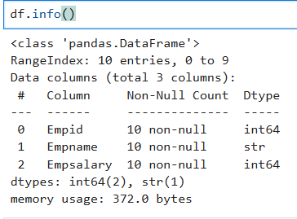
- df.describe() it shows all details
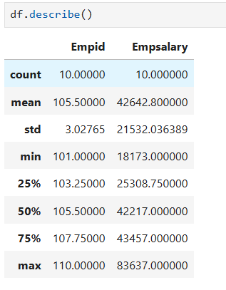
- np.nan used to create not a number if you want to do blank data you cant you can use np.nan
data = {
'Empid': [101,102,103,104,105,106,107,108,109,110],
'Empname': ['Ram','Shyam','Mohan' , np.nan,'Anu','Riya','Simran','Nameera' ,'Mohit','Bhavna '],
'Empsalary':[42121,43232,21331,43532,83637,37212,18173,73536,21341,42313]
}
- df.info() it shows how many data are null
- df.isnull() it shows missing value in form of True and False (jha missing hai vha true aa jayga)
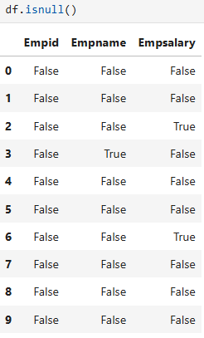
- df.isnull().sum() ye column wise jod kar btayga null hai ya nahi ex: 0 ,1,2
- df.isnull().sum().sum ye tino ko jod dega 0+1+23
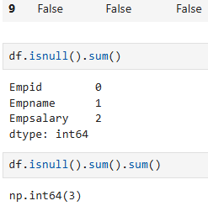
- df.dropna() it remove null column but not change in original column

#Replace
- df.fillna(‘Not Found’) ye sb jagah not found kr dega but
  - isse integer bhi str bn jayga jab ham salary calculate krege to max sum kuch run nahi hoga
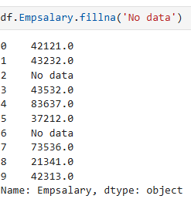 you can do on selected table but focus type has been changed

- Correct
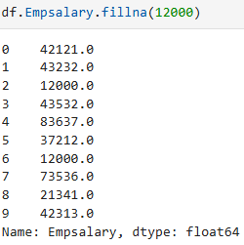
And
df.Empsalary.fillna(df.Empsalary.mean())

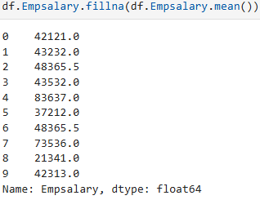

- newdf = df.copy() it is used to create copy
  - newdf.Empsalary = newdf.Empsalary.fillna(round(newdf.Empsalary.mean(),2)) fill by values
- len(df) it is used to find to total length (total employees)
  - df.shape (15,6) 15 row 6 column
    - df.shape[0] its return tuple 0 represent rows
    - df.shape[1] its return tuple 1 represent cloumn
  - df.EmpID.count() it can be used where nonull values if null values exist it ignore
- df.dtypes it is used to find the each column of datatype
- df[[‘Salary’ , ‘Department’ , ‘Age’]] it show only these column
- df.columns it is used to see all columns
- df[columnname].unique()it is used to see all unique values
- df[columnname].value_counts () it is used to count the number of values comes (means is column mai itne baar ye naam aaya hai )
- mode() is used to select maximum time element occur
- df.select_dtypes(include=str) ye vo data dikhayga jo str type ka hai bs
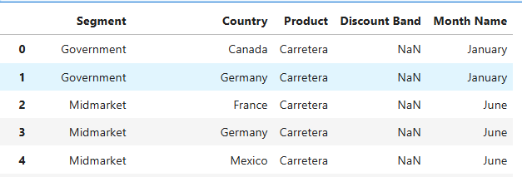
- # it shows mode values comes on index 0
df.Segment.mode() #it show index
df.Segment.mode()[0] #it shows value on index 0
- for col in df.select_dtypes(include = np.number) it select both float and int
- Lambda function df['Country'].map(lambda val : val[0:3])
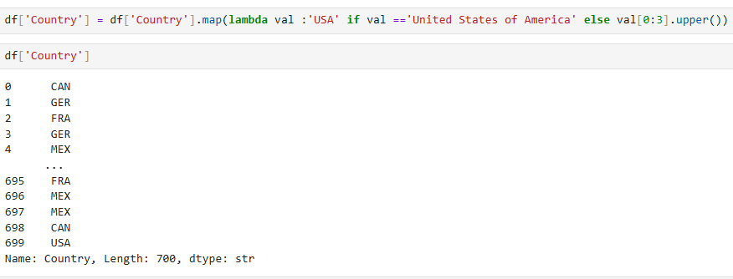
- df = df.drop(columns=['Month Number' , 'Month Name' , 'Year' ]) if you want to drop columns and you want drop single column
  - df = df.drop(columns='Year' ) use quotes ‘ ‘
- SAVE THE DATA INTO FILE
  - df.to_excel(“Name”)
  - df.to_csv(“Cleaned_data.csv”)
  - df.to_json(“Cleaned_data.json”)
  - df.to_list(“Cleaned_data.li”)
- WithOUT INDEX
  - df.to_csv("Cleaned_Data_0003_Practical.csv" , index =False)

- plot function
- #The Pandas Plot()
- #!pip install matplotlib
- import matplotlib.pyplot as plt
- data['winner'].value_counts().plot(kind='bar')
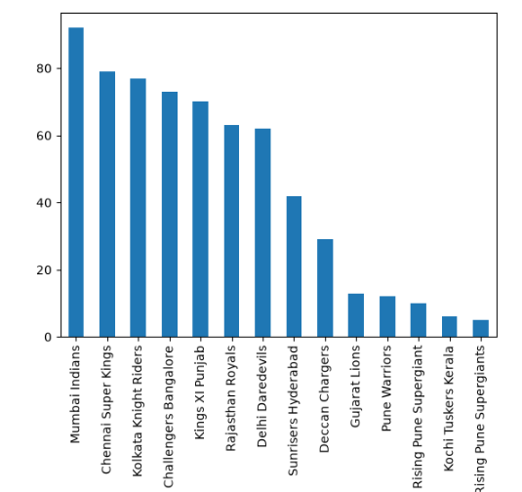

- if you want only top team
  - data['winner'].value_counts().head().plot(kind='barh') h is used for horizontal
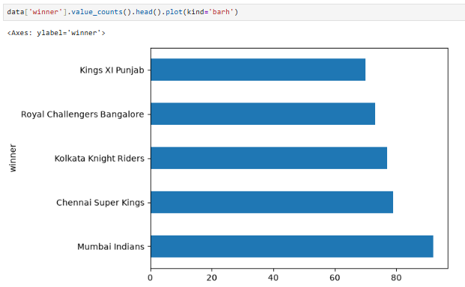

- myseries.index index is attribute is used to show the all index
- myseries.valuesit get all the values
- data.sort_values it apply on both dataframe and series for sorting values.
  - By default = Ascending order
- Data(, inplace = True ) inplace = True it is the parameter to change permanently into data , it is by default False
  - data.sort_values('city' , ascending = True)
  - data.sort_values(['city' , 'date'] , ascending = [True , False])
- data.drop_duplicates(subset = ['city']) it is used to drop duplicates
  - we can pass multiple list like city , season , winner and etc
  - data.drop_duplicates(subset = ['season'] , keep = 'last')[['season' , 'winner']]
    - it is used to find final match winner that’s why we use ‘last’
- isin() only pass list in the isin parameter
  - mask agar bhot sare ban rahe hai to isin ka use karege
- merge() like join in sql
Example: new = delivery.merge(match , left_on = 'match_id' , right_on = 'id')
- reset_index() used to convert a series into DataFrame
  - used to remove unwanted index
- set_index( ) when you want to make existing column (eg : id ) to index without python giving index
Before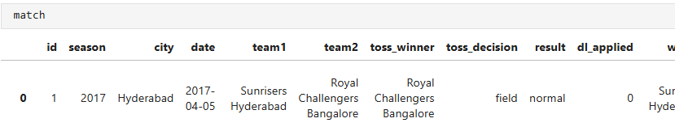 After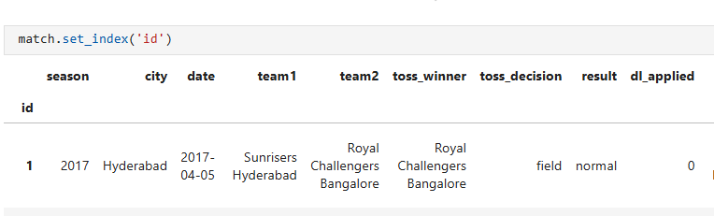
- pivot_table() it convert into useful table according to pt = datframename.pivot_table(index = 'over' , columns = 'batting_team' , values ='batsman_runs' , aggfunc='count')
- heat_map() usedin seaborn
  - import seaborn as sns
  - sns.heatmap(pt)
- corr() it works only numerical data it remove the string data
  - match.corr(numeric_only=True)

-------------------------------------------------------------------------
GROUP
- Group
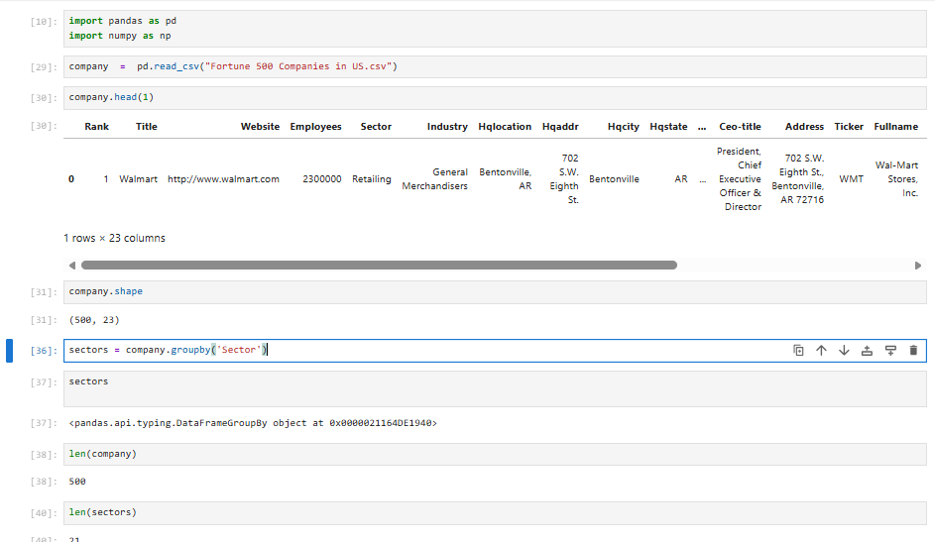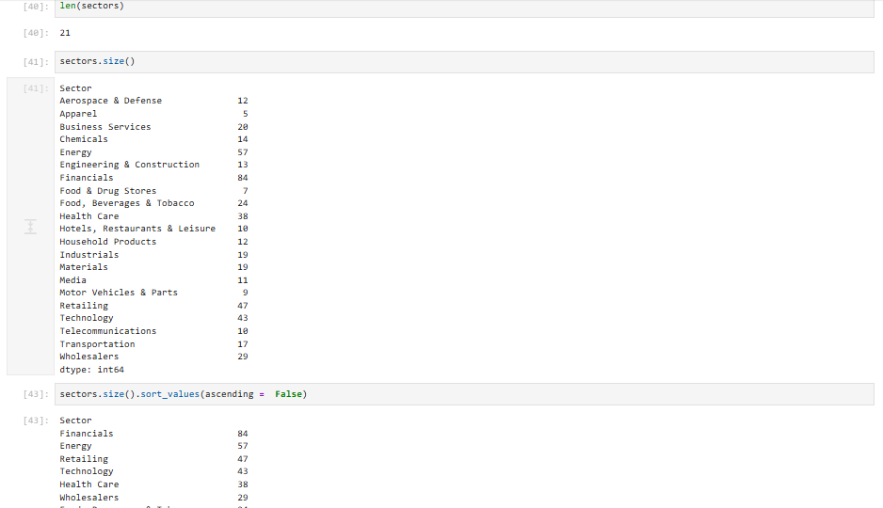
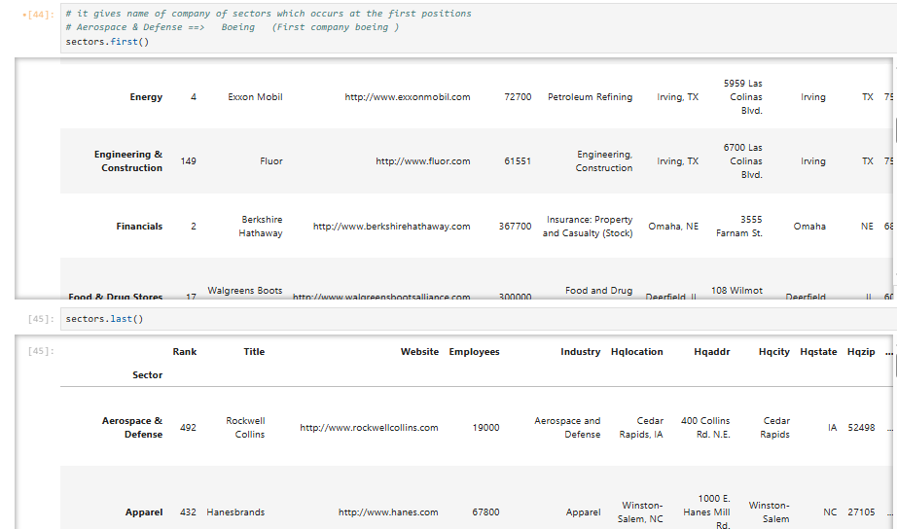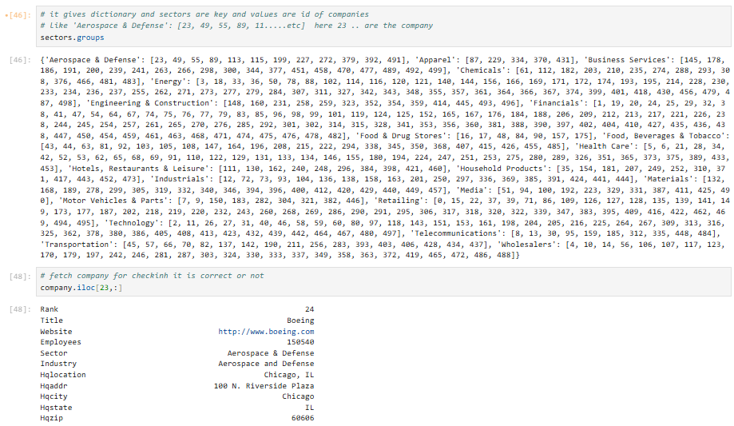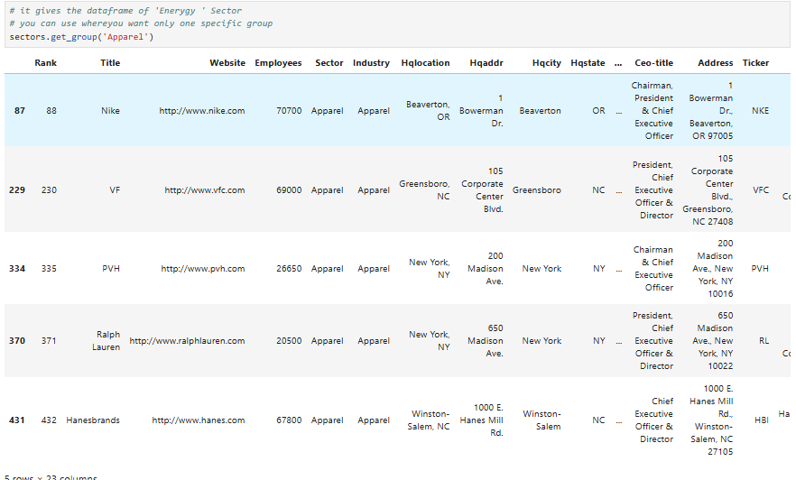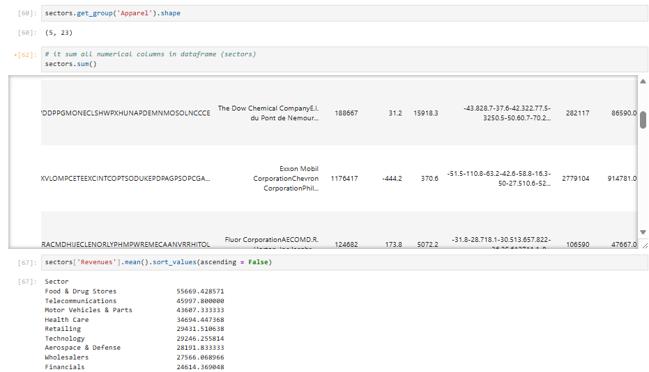
===================================================================================================================================

MATPLOTLIB
Matplotlib is a low level ploting library

- import matplotlib.pyplot as plt
- plt.figure(figsize = (8,3))
plt.bar(pbp['Product'] , pbp['Profit'])
- plt.figure(figsize= (8,3))
plt.bar(pbs['Segment'] , pbs.Profit , color = 'pink')
- plt.figure(figsize = (8 , 3))
plt.bar(pbs.Segment , pbs.Profit , , 'pink' , 'green', 'yellow'])
- colors = list(pbs['Profit'].map(lambda val : 'green' if val>0 else 'red'))
- plt.figure(figsize = (8, 3))
plt.bar(pbs['Segment'] , pbs['Profit'] , color = colors)
plt.show()
- #LineChart
plt.figure(figsize= (8,3))
plt.plot(pbp['Product'] , pbp.Profit)
plt.show()
- import numpy as np
- x = np.arange(1, 31 ,1)
y = np.random.randint(100 , 1000 ,30)
- plt.figure(figsize = (8 ,3))
plt.plot(x , y , 'o')
plt.show()
- plt.figure(figsize = (8 ,3))
plt.plot(x , y , marker = 'o' )
plt.show()
- # mfc MArker Face Color
plt.figure(figsize = (8 ,3))
plt.plot(x , y , marker = 'o' , mfc = 'red')
plt.show()
- # ms = Marker Size
# mfc MArker Face Color
plt.figure(figsize = (8 ,3))
plt.plot(x , y , marker = 'o' , mfc = 'red' , ms = 8)
plt.show()
- #mec = marker edges color
# mfc MArker Face Color
plt.figure(figsize = (8 ,3))
plt.plot(x , y , marker = 'o' , mfc = 'red' , mec = 'green')
plt.show()
- # line color change
# mfc MArker Face Color
plt.figure(figsize = (8 ,3))
plt.plot(x , y , marker = 'o' , mfc = 'red' , mec = 'green' , color = 'yellow')
plt.show()
- #linestyle
plt.figure(figsize = (8 ,3))
plt.plot(x , y , marker = 'o' , mfc = 'red' , mec = 'green' , color = 'yellow' , linestyle= 'dashed')
plt.show()
- #linestyle = ls
plt.figure(figsize = (8 ,3))
plt.plot(x , y , marker = 'o' , mfc = 'red' , mec = 'green' , color = 'green' , ls= '-.')
plt.show()
- plt.figure(figsize = (8 , 3))
plt.pie(pbp['Profit'] )
plt.show()
- plt.figure(figsize = (8 , 3))
plt.pie(pbp['Profit'] , labels = pbp['Product'] )
plt.show()
- plt.figure(figsize = (8 , 3))
plt.pie(pbp['Profit'] , labels = pbp['Product'] , autopct = '%0.3f%%')
plt.show()
- plt.figure(figsize = (8 , 3))
plt.pie(pbp['Profit'] , labels = pbp['Product'] , autopct = '%0.0f%%')
plt.show()
- #loc= location
plt.figure(figsize = (8, 3))
plt.bar(pbs['Segment'] , pbs['Profit'] , color = colors)
plt.xlabel("Name of Segment")
plt.ylabel('Profit in INR (Crore)')
plt.title('Profit of Segment' , loc = 'Right')
plt.show()

==================================================================================================================================
SEABORN Seaborn is written on Matplotlib
- #!pip install seaborn
import seaborn
- seaborn.__version__
- import seaborn as sns
import pandas as pd
import numpy as np
import matplotlib.pyplot as plt
- df = pd.read_excel("Financial_Sample.xlsx")
- df.isnull().sum()
- sns.heatmap(df.isnull())
- plt.figure(figsize=(6,3))
sns.heatmap(df.isnull())
plt.show()
- df.select_dtypes(include = np.number).columns
- plt.figure(figsize=(12, 4))
sns.boxplot(df.select_dtypes(include = np.number))
plt.show()
- plt.figure(figsize = (12,4))
sns.lineplot(df.select_dtypes(include = int))
plt.show()
- sns.get_dataset_names()
- sns.load_dataset('taxis')

